EXPERIMENT-19
19) Implement the Erosion Morphological operations technique using Open CV in python.

a)CODE
import cv2
import numpy as np

img = cv2.imread(r"C:\Users\Varshini varshini\Desktop\photo.jpg")
kernel = np.ones((5, 5), np.uint8)

erosion = cv2.erode(img, kernel, iterations=1)

cv2.imwrite(r"C:\Users\Varshini varshini\Desktop\erosion.jpg", erosion)

cv2.imshow("Erosion Image", erosion)
cv2.waitKey(0)
cv2.destroyAllWindows()

b) INPUT
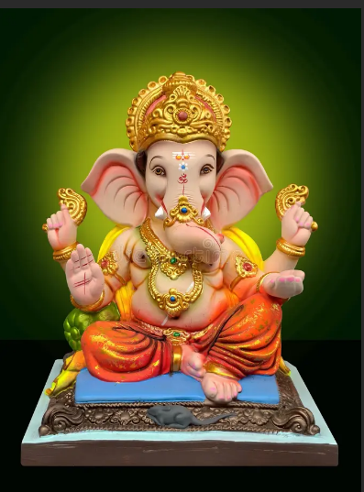

C) OUPUT
